**Report of bugs and Issue found**

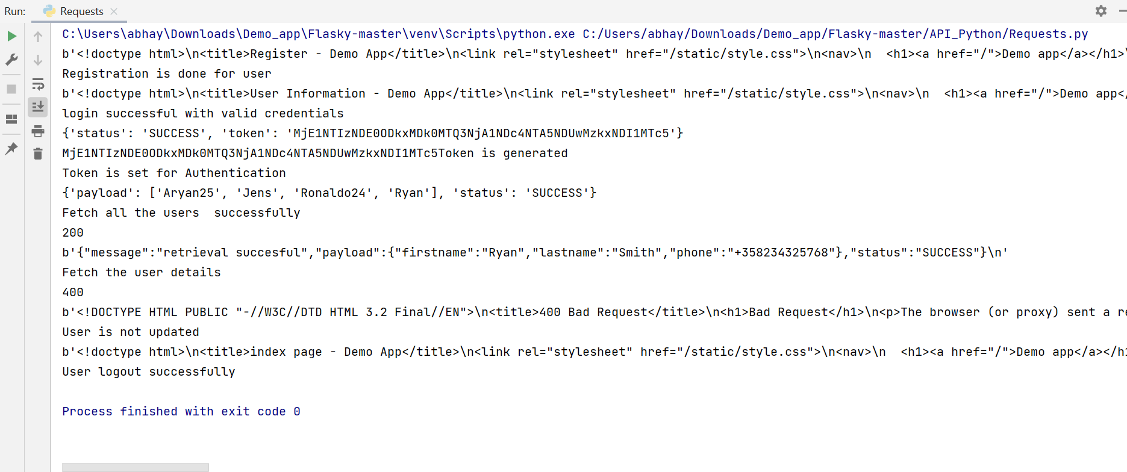

While doing test run for API Automation with python, we need to perform basic operations on server.

1. Register the user with POST request.
2. Login the valid user with POST request. (“username”, “password”)
3. Fetching the Token with GET request with valid user credentials.
4. Access the token and set it back to Get the user details.

**BUG**

1. Updating the user detail with the token given but its not updating the user details.